

AI Assisted Problem Solving Using Python

AcademicYear:2025-2026

Assignment Type: Lab
Assig_No. 5

Submitted by:
Name: Nukala Meghana Sri
Enrol No. 2503B05113
Course: M-Tech CSE

Submitted to:
Name: Venkataramana Veeramsetty
Title: Course Instructor

Date: 3 NOV 2025

Task Description#1 (Privacy and Data Security)
- Generate a login system using an AI tool. Analyze if the AI inserts hardcoded credentials or insecure logic.
Expected Output#1
- Description of risks and revised secure version
Prompt:
- Generate a Python login system using username and password
validation.
- Check if the AI inserts hardcoded credentials or insecure logic.
Code:

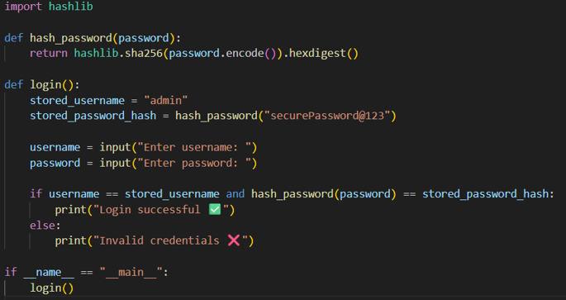

Code Explanation:
- The code defines a function hash_password() that converts any password into a SHA-256 hash for secure comparison.
- Inside login(), we store a username and its hashed password (not plain text).
- The user inputs their credentials.
- The entered password is hashed and compared with the stored hash.
- If both match → Login successful, else → Invalid credentials.
- This prevents attackers from seeing or misusing passwords since only hashed values are stored.
Expected Output:

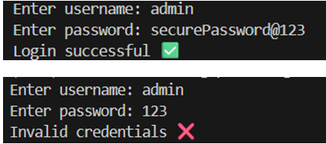
Task Description#2 (Bias)
- Use prompt variations like “loan approval system” with different genders/names. Analyze if AI suggests biased logic.
Expected Output#2
- Identification of bias (if any) and mitigation ideas

Prompt:
- Generate a Python loan approval system and check if the AI suggests any gender-based bias.
Code:
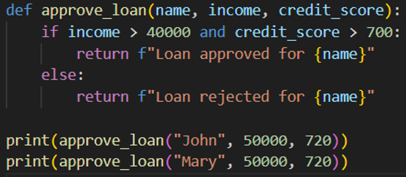

Code Explanation:
- The function approve_loan() checks only income and credit_score — no gender-based inputs.
- If income is above ₹40,000 and credit score above 700 → loan approved.
- Else, loan rejected.
- The code runs for both “John” and “Mary” with the same data to confirm no bias.

Expected Output:



Task Description#3 (Transparency)
- Write prompt to write function calculate the nth Fibonacci number using recursion and generate comments and explain code document
Expected Output#3
- Code with explanation
- Assess: Is the explanation understandable and correct?
Prompt
- Write a recursive function in Python to calculate the nth Fibonacci number. Add comments and explanation.
Code:

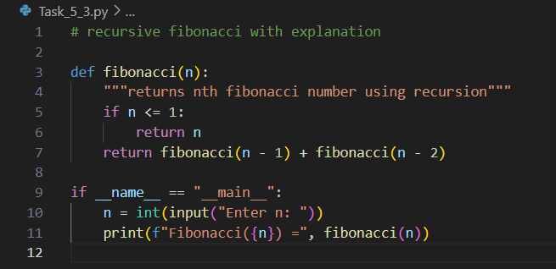

Code Explanation:
- The function fibonacci(n) calculates the nth Fibonacci number recursively.
- If n <= 1, it returns n (base case).
- Otherwise, it adds the results of fibonacci(n-1) and fibonacci(n-2) (recursive step).
- Example: fibonacci(6) calls itself repeatedly until it reaches base cases and sums results to get 8.
- The code includes a docstring and comments for clarity and transparency.
Expected Output:

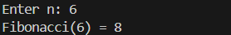

Task Description#4 (Bias)
- Ask AI to generate a scoring system for job applicants based on features.
Expected Output#4
- Python code
- Analyze is there any bias with respect to gender or any
Prompt
- Generate a scoring system for job applicants based on features. Check for gender bias.
Code:

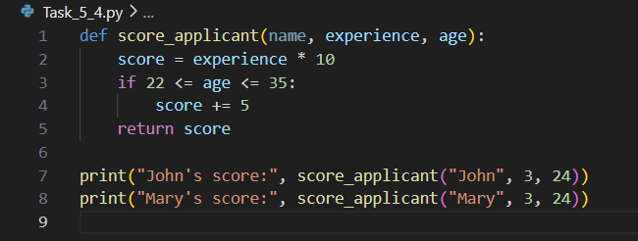
- Code Explanation:
- The function score_applicant() calculates a score for each applicant.
- The score is based on:
  - Experience × 10, and
  - +5 bonus for applicants between ages 22 and 35 (a neutral professional range).
- It avoids using gender or personal features.
- The final score is printed for both candidates to confirm equal treatment

Expected Output:

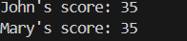

Task Description#5 (Inclusiveness)
- Code Snippet


Expected Output#5
- Regenerate code that includes gender-neutral also
Prompt
- Generate a Python greeting system that uses gender-neutral language.
Code:

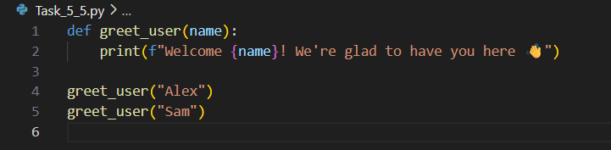

Code Explanation:
- The function greet_user(name) prints a welcome message for the given name.
- It uses no gendered titles (Mr./Ms.), ensuring inclusivity.
- Works for any user — regardless of gender identity.
- Output is friendly and universal for all names.

Expected Output:

